

CSA15 Cloud Computing and Big Data Analytics
CO1 AT2 - Digital Concept Map and Service Model Matrix
Individual Student Submission Template

Student and Faculty Details

Student Name | G. Lakshmi Mounika | Register Number | 192372110
Class / Section |  | Slot | B
Course Code | CSA1512 | Course Title | Cloud Computing and big data analytics
Capstone Title | CropWater AI: Irrigation Scheduling and Water Stress App
Submission Date | 13-07-26
Faculty Name | DR. Rajesh babu.C | Employee ID
Department | CSE(AI)

Assessment Brief

Course Outcome | CO1 - Explain the evolution, architecture, characteristics, service models, and emerging paradigms of cloud computing.
Assessment Type | Individual concept mapping, service-model responsibility analysis, and capstone-cloud interpretation.
Assessment Focus | Each map must show key nodes, link labels, relationship meaning, and a logical hierarchy. The response must connect cloud fundamentals to the student's own perception of the capstone title.
Submission Mode | Editable DOCX + exported diagram evidence + GitHub repository link submitted in Google Classroom.
Permitted Tools | draw.io / diagrams.net, Lucidchart, Miro, Canva, PowerPoint, Google Drawings, or equivalent diagramming tool.
Individual Rule | Every student must submit their own concept map, matrix, capstone-cloud mapping, and reflection. The capstone title may be shared by a team, but the assessment answer must not be common.
Total Marks | 100 marks

Code of Conduct and Student Assurance

Academic Integrity Statement
This assessment must be completed individually. Students may discuss the capstone domain with their team, but the concept map, service model matrix, explanations, GitHub evidence, and reflection submitted here must be individually prepared.
Student Assurance | I confirm that this submission represents my own understanding of CO1 concepts and my individual interpretation of the selected capstone title.
Tool Use | I have used digital tools only for diagram preparation, organization, and presentation. I have not copied another student's diagram, matrix, or explanation.
Evidence | I have uploaded the required files to my GitHub repository and submitted the repository link / evidence link through Google Classroom.

Student Signature | G. Lakshmi Mounika
Date | 13-07-26

Procedure for Preparing the Digital Concept Map

Use the following procedure to prepare the diagram and upload evidence. Students who already know another diagramming tool may use it, but the exported evidence and source file must still be submitted.
- Open https://app.diagrams.net/ or the desktop version of draw.io / diagrams.net.
- Choose Device, Google Drive, or OneDrive as the save location according to availability.
- Create a blank diagram and name the file as CSA15_CO1_AT2_RegisterNumber_Concept_Map.drawio.
- Place the capstone title at the center or as a clearly visible anchor node.
- Add major cloud nodes: cloud definition, cloud evolution, cloud architecture, service models, deployment models, virtualization, web services, SOAP, REST, APIs, elasticity, scalability, resource pooling, measured service, and emerging paradigms.
- Connect nodes with labeled arrows such as uses, depends on, enables, scales through, communicates through, belongs to, supports, provides, consumes, or controls.
- Use colors meaningfully: one color for service models, one for cloud characteristics, one for API/web-service concepts, and one for capstone-specific elements.
- Export the final diagram as PNG or PDF. Keep the editable .drawio source file also.
- Paste the exported diagram image or screenshot in this DOCX under Task 1.
- Upload the DOCX, exported PNG/PDF, and .drawio file to GitHub, then submit the GitHub link in Google Classroom.

GitHub Submission Procedure

Step | Required Action | Expected Evidence
1 | Create or use your individual GitHub account. | GitHub profile link.
2 | Create a repository named  CSA15-CO-Assessments-RegisterNum ber or use the repository instructed by faculty. | Repository URL.
3 | Create a folder named CO1_AT2 inside the repository. | Folder visible in repository.
4 | Upload this completed DOCX, exported diagram PNG/PDF, and editable .drawio source file. | At least three evidence files uploaded.
5 | Add a short README.md explaining the capstone title and files submitted. | README visible in the AT2 folder.
6 | Submit the GitHub folder link in Google Classroom. | GCR submission with repository/folder link.

Assessment Questions and Student Response Sections
Important
The capstone project may be developed by a team, but every response below must be written from the individual student's own perspective. Do not submit a common team answer.

Task 1 - Digital Cloud Concept Map

Create one integrated digital concept map for CO1. The map must show key nodes, link labels, relationship meaning, and a logical hierarchy. It must also connect the concepts to your selected capstone title from your individual perspective.

Mandatory Concept Group | Minimum Concepts / Nodes to Include
Cloud Fundamentals | Definition, characteristics, benefits, limitations, on-demand access, measured service.
Cloud Evolution and Drivers | Hardware evolution, internet software evolution, distributed systems, cost economics, mobility, remote access, big data growth.
Architecture and Deployment | Front-end, back-end, network layer, data center, management software, public/private/hybrid/community cloud.
Service Models and Responsibility | IaaS, PaaS, SaaS, XaaS, provider responsibility, user responsibility, shared responsibility.
Virtualization and Web/API Layer | Virtual machine, hypervisor, abstraction, resource pooling, multi-tenancy, web services, SOAP, REST, API request/response.
Capstone Connection | Your capstone users, app/module, cloud backend, database/storage, dashboard/analytics, scalability and elasticity idea.
Paste exported concept map image / screenshot here. Resize neatly within this white space.

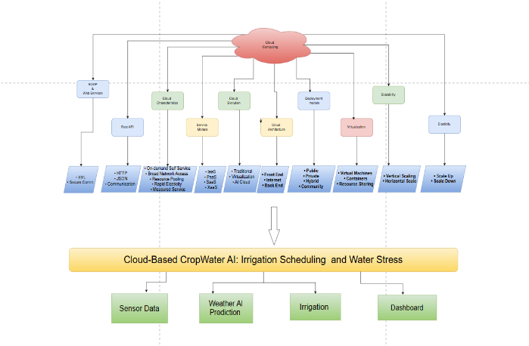
Brief explanation of your concept map: explain the most important nodes, link labels, hierarchy, and capstone connection.
The concept map explains how Cloud Computing is used in the Cloud-Based CropWater AI: Irrigation Scheduling and Water Stress project. It includes key cloud concepts such as cloud characteristics, architecture, deployment models, service models, virtualization, REST API, SOAP web services, elasticity, and scalability. The project collects sensor and weather data, processes it using cloud-based AI, and provides irrigation recommendations through a farmer dashboard. Cloud computing enables secure storage, real-time data processing, and scalable services, making the irrigation system efficient and reliable.

Task 2 - Service Model Matrix
Complete the matrices by making technical decisions for your capstone project. Select only the rows that are relevant to your capstone design. If a row is not used, write a short technical reason instead of leaving it blank.
Your answer should show how responsibility shifts between cloud provider and student development team, and how the chosen services support the capstone workflow, API design, storage, security, scalability, and evidence submission.

Task 2A - Service Model Responsibility Matrix

Service Model | Capstone Role / Module | Provider Responsibility | Student Responsibility | Evidence to Submit
IaaS | Cloud server and storage | Provides virtual machines, storage, and networking | Configure and manage application deployment | Cloud architecture diagram
PaaS | AI application Development | Provides development platform and runtime | Develop, test, and deploy the application | Source code / GitHub
SaaS | Farmer Dashboard | Hosts and delivers the web application | Design user interface and application features | Application screenshots
XaaS / Specialized Service | Weather API&AI Prediction | Provides weather data and AI services | Integrate APIs and generate irrigation recommendations | API integration evidence

Task 2B - Capstone Cloud Service Decision Matrix

Cloud Layer / Function | Selected Tool or Service | Data / Resource Handled | API or Integration Path | Security / Scaling Note
Client access and UI | Farmer Dashboard | User Requests | REST API | Secure Login
API / backend logic | REST API | Sensor & Weather Data | HTTP/JSON | Scalable Backend
Authentication and identity | User Login | User Credentials | Login API | Authentication
Database / structured records | Cloud Database | Sensor Data & Irrigation Records | Database Connection | Backup & Encryption
File / object storage | Cloud Storage | Reports & Images | Storage API | Secure Storage
Monitoring / logs / usage metrics | Cloud Monitoring | System Logs | Monitoring Service | Auto Monitoring
Analytics / reporting output | AI Prediction Engine | Water Stress Prediction | AI Model API | Elastic & Scalable
Technical justification: Explain why the selected cloud service pattern fits your capstone project's users, data, API flow, scalability, and security needs.
The CropWater AI project uses cloud services to securely collect, process, and store sensor and weather data. REST APIs enable communication between the application and the cloud backend. AI services analyze the collected data to predict water stress and provide irrigation recommendations. Cloud computing offers scalability, security, and real-time access, making the system efficient and reliable for farmers.

Task 3 - Capstone Cloud Flow Mapping

Study the sample architecture-flow template below. Redraw it in draw.io / diagrams.net using your own capstone architecture. Replace every generic label with your actual user role, screen, API endpoint, backend logic, cloud storage, analytics output, security control, and scalability or elasticity decision.

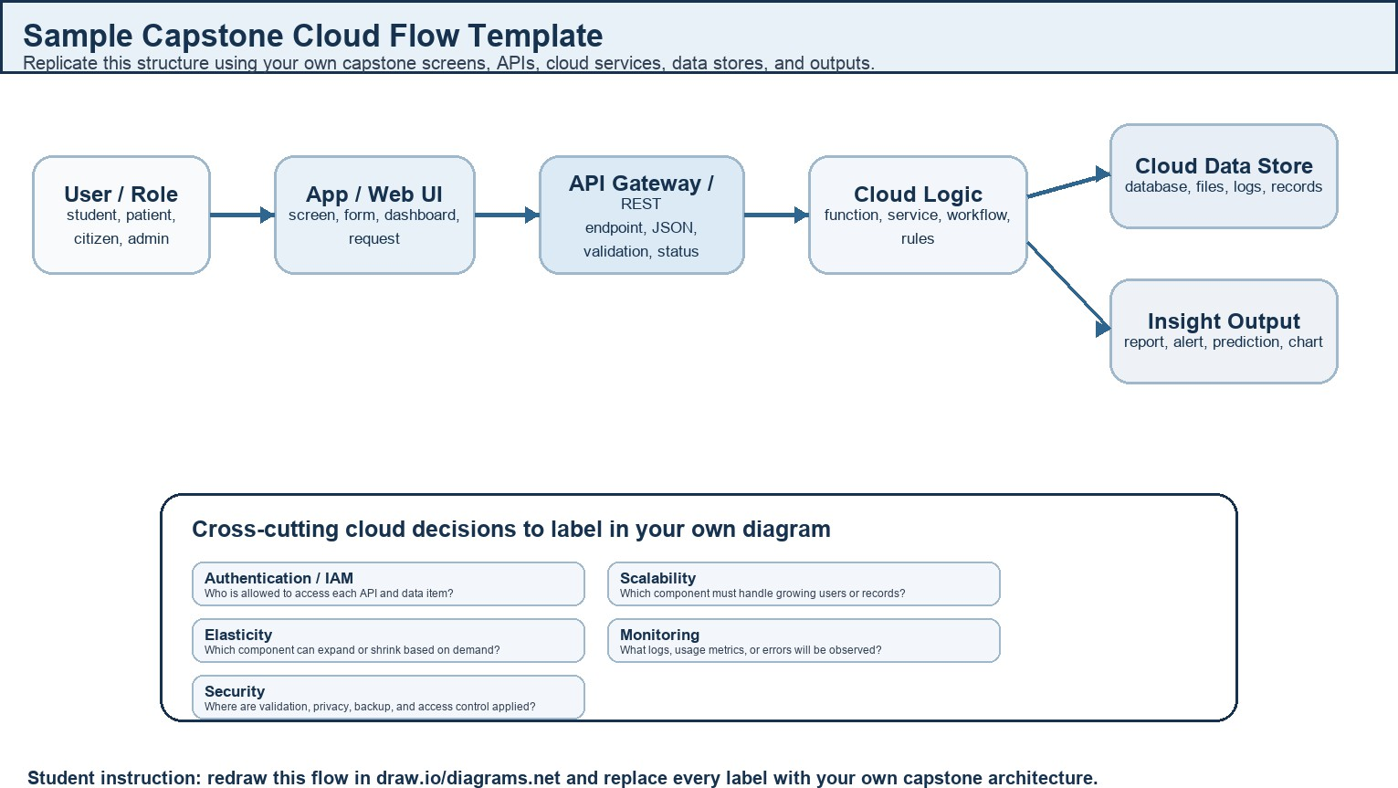

Student Drawing Requirement
Do not copy the sample as it is. Use it as a layout model, then create your own capstone-specific flow diagram with
meaningful labels, arrows, data movement, API names, and cloud service choices.
Flow Component | Student Entry
User role and action | Farmer enters crop details and requests irrigation recommendations.
Frontend / app screen | CropWater AI Web/Mobile Application Dashboard.
API endpoint and method | REST API (HTTP/JSON) to send sensor and weather data to the cloud server.
Backend processing rule | Cloud server processes sensor and weather data using the AI prediction model to determine water stress and irrigation schedule.
Cloud database / storage operation | Stores user information, sensor data, weather data, and irrigation records in the cloud database.
Response, alert, report, or dashboard output | Displays irrigation recommendations, water stress alerts, and dashboard reports to the farmer.
Security, scalability, and elasticity labels added in diagram | Authentication, Secure Cloud Storage, Scalability, and Elasticity for handling multiple users and real-time data.
Paste your redrawn capstone cloud-flow diagram here.

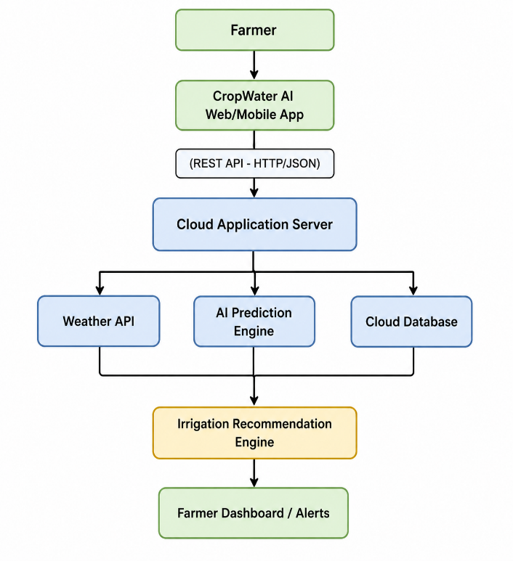
Brief explanation: explain one complete
request-response path from user action to cloud response.
The farmer accesses the CropWater AI application through a web or mobile interface. The application sends requests to the cloud server using REST APIs. The server collects sensor and weather data, stores it in the cloud database, and processes it using the AI prediction model. Based on the analysis, the system generates irrigation recommendations and displays them on the farmer dashboard. Security mechanisms protect user data, while cloud scalability and elasticity ensure efficient performance as the number of users and data increases.

Task 4 - Individual Reflection

Answer the following from your own perspective. Avoid team-common wording.

- What is the strongest cloud concept represented in your capstone project?

The strongest cloud concept in my capstone project is cloud scalability. It allows the system to handle increasing amounts of sensor and weather data efficiently.
- Where will elasticity or scalability become important in your capstone product?

Elasticity and scalability become important when many farmers use the application at the same time. The cloud can automatically manage resources to ensure smooth performance.
- Which API or web-service idea is most relevant to your project and why?

The REST API is the most relevant because it enables communication between the mobile application, cloud server, and weather data services for real-time irrigation recommendations.
- What did you personally understand better after preparing this concept map and matrix?

I understood how cloud computing concepts such as service models, cloud architecture, APIs, scalability, and elasticity work together to support real-world applications like my CropWater AI project.

Evaluation Rubric - 100 Marks

Criteria | Marks | Expected Standard
Concept identification | 20 | Major CO1 concepts are accurately identified: cloud fundamentals, characteristics, evolution, service models, deployment models, virtualization, web services, SOAP/REST, APIs, elasticity, and scalability.
Relationship mapping | 20 | Links between concepts are accurate, meaningful, and labeled. The map should explain how concepts depend on, enable, consume, provide, scale, or control one another.
Hierarchy and organization | 15 | Concepts are arranged in a logical hierarchy with clear grouping, readable flow, and no disconnected keyword clusters.

Technical relevance | 15 | The map strongly reflects cloud course content and avoids decorative or generic non-technical content.
Service model matrix | 15 | IaaS, PaaS, SaaS, and XaaS are compared with provider responsibility, user responsibility, examples, capstone usage, and risks or limitations.
Capstone alignment and individual reflection | 10 | The student's own capstone interpretation is visible in the concept map, flow mapping, justification, and reflection. Team-common answers are avoided.
Visual clarity and digital evidence | 5 | Diagram is neat, readable, exported properly, and supported with GitHub evidence including source and exported files.

Faculty Evaluation Record

Evaluator Name |  | Marks Awarded
Observation |  | Signature

